ROM FILE MAKER MANUAL
V2.5

 | Wiznet,Inc  Copyright 2002 WIZnet, Inc. All Rights Reserved.  Technical Support: support@wiznet.co.kr  Sales & Distribution: sales@wiznet.co.kr  General Information: info@wiznet.co.kr
For more information,
visit our website at http://www.iinchip.com or http://www.wiznet.co.kr
CONTENTS
1 What is ‘ROM File System’? 3
2 About ‘ROM File Maker’ 4
3 Installation 4
4 How to use 4

FIGURES
<Fig 1.1> Structure of iinChip™ EVB B/D’s ROM File System 3
<Fig 4.1> ROM File Maker execution 5
<Fig 4.2> EVB-A1’s “types.h” 6
<Fig 4.3> ‘ROM File’ additional files list 7
<Fig 4.4> ‘ROM File System’ creating completion 7
<Fig 4.5> “romfs.h” 8
<Fig 4.6> “romfs.c” 9

TABLES
<Table 2-1> search_file() 4

What is ‘ROM File System’?
‘ROM Files’ of iinChip™ EVB B/D means loaded files in Code Memory Area(i.e. ROM,Flash, etc). Each ROM File is made up of File Name, File Size and File Contents. Each contents of ROM File are converted into Binary Code and are loaded in ROM( Hence, we mention the loaded contents to ‘ROM Image”.)
Originally, ‘ROM File System’ is designed for easier management of ‘ROM File’. This system defines each ‘ROM File’ as ROMFILE which is File Node Structure and manages them through romfs_list which makes you possible to refer ROMFILEs orderly.
When you handle various files (i.e. web page files (HTML, JPEG, GIF)) for development iinChip™ EVB,’ROM File System’ helps you develop efficiently and manage easily.
Following figure introduces the structure of EVB B/D’s ROM File System. You can see the correlation between ROMFILEs as well as ROMFILE and ROM Image as shown in <Fig 1.1>.
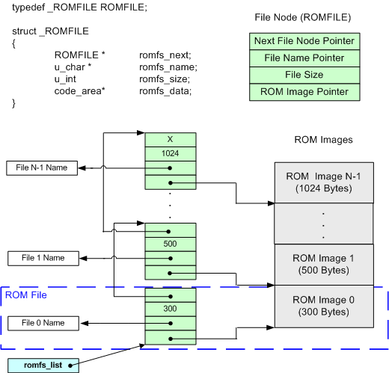
<Fig 1.1> Structure of iinChip™ EVB B/D’s ROM File System
As shown in <Fig 1.1>, ‘ROM Image’ is located in iinChip™ EVB B/D’s ROM and romfs_list, which is the Linked List of File Nodes is located in EVB B/D’s RAM.

About ‘ROM File Maker’
‘ROM File Maker’ is the composition tool for ‘ROM File System’, Window-based PC program. It is required when you develop iinChip™ EVB F/W.

‘ROM File Maker’ executes ROMFILE Structure definition, ‘ROM Image’ creation, ‘ROM File’ search function, and Source Files(romfs.h & romfs.c) written in C Language.

You can search each ‘ROM File’ in ‘ROM File System’ using ‘search_file()’.

Following Table is the explanation about search_file().
<Table 2-1> search_file()
Prototype | u_char search_file(u_char * name, code_area ** buf, u_int * len)
Parameter | name | searching ROM File Name
Parameter | buf | searched ROM File Location Return
Parameter | len | searched ROM File Size Return
Result | > 0 : Success, 0 : Fail

Installation
You can install ‘ROM File Maker’ through executing “RFMaker VX.X.exe”
iinChip™ EVB B/D’s Software CD provides this install file. Moreover, you can download the latest version of install file from the manufacturer ‘WIZnet’ homepage(www.wiznet.co.kr)

How to use
- Please execute “RFMaker.exe”
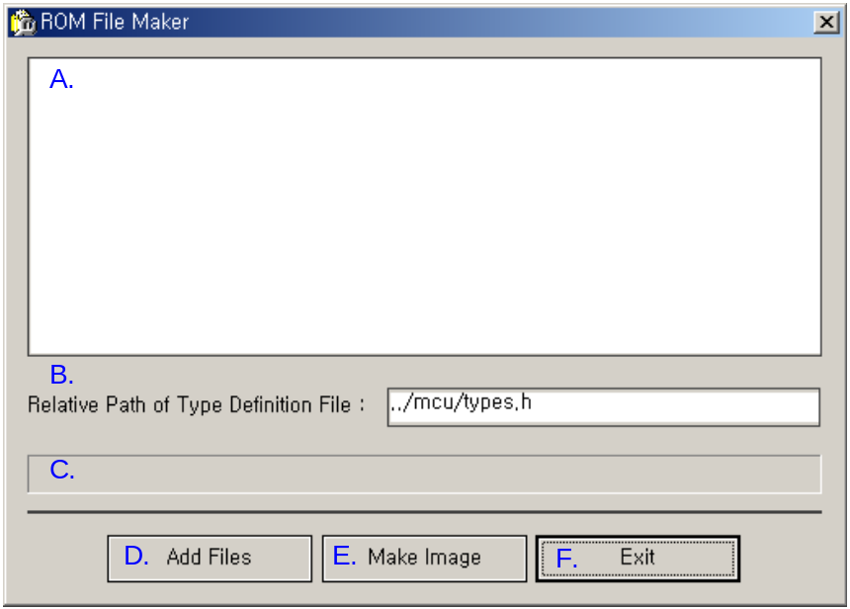
<Fig 4.2> ROM File Maker execution
  - File List
  - Relative Path Name that is defined as Data Type used in iinChip™ EVB B/D
  - ‘ROM File System’ creation process.
  - Add the file that would be formed into ‘ROM File’
  - ‘ROM File System’ creation
  - Program shut down.

- Please appoint Relative Path about the file defined “code_area”Type.
<Attention!> You should define “code_area” Type in the appointed file necessarily. The reason why “code_area” Type is using CODE Memory Type that is referred in “romfs.h” and “romfs.c”.

iinChip™ EVB F/W defines “code_area” Type of “types.h” as shown in <fig 4.2>
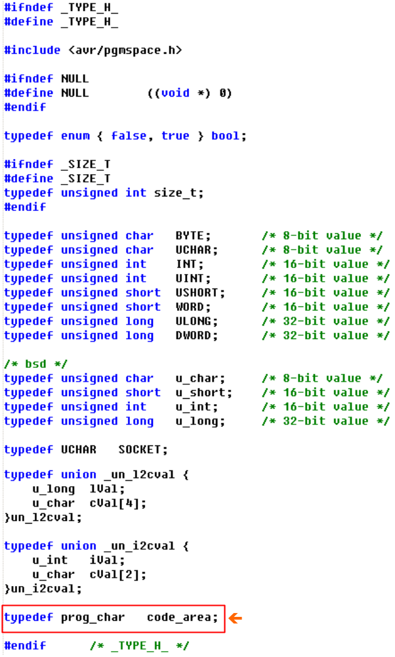
<Fig 4.3> EVB-A1’s “types.h”
- Please click ‘Add File’ button.
In “File Open Dialog”,select files that you are willing to add into ‘ROM File System’.
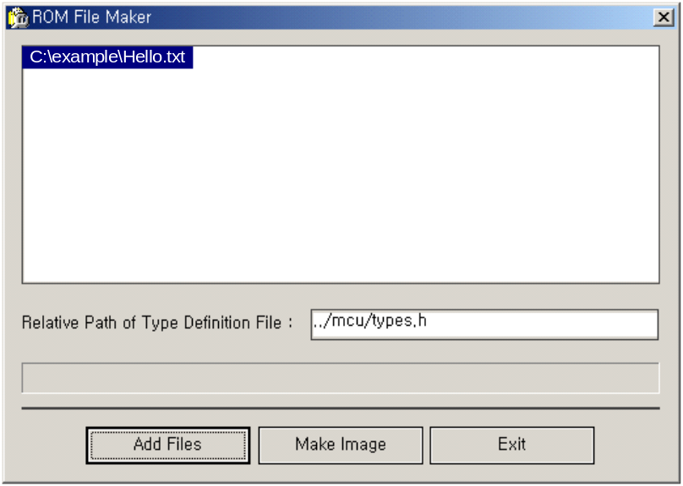
<Fig 4.4> ‘ROM File’ additional files list

- Please create ‘ROM File System’ through the click of ‘Make Image’ button.
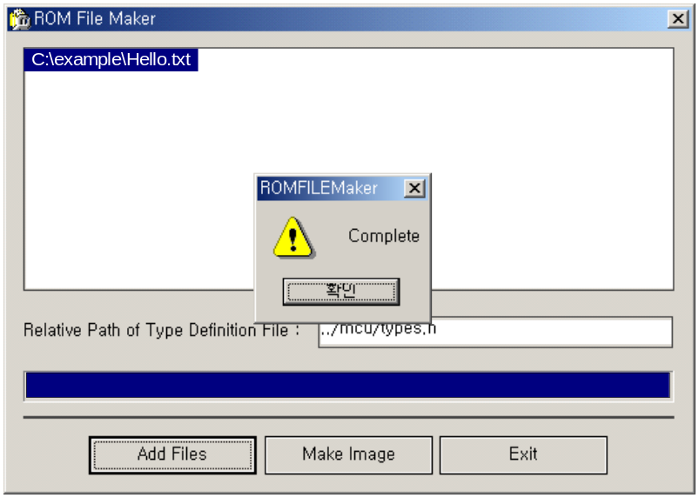
<Fig 4.5> ‘ROM File System’ creating completion
‘ROM File System’ creating process is formed out of ‘C Language Source File’ of ‘romfs.h’ and ‘forfs.c’.
If you add “romfs.h” and “romfs.c” into iinChip™ EVB F/Ws Project and compile, the embodiment of ‘ROM File System’ easily is completed.
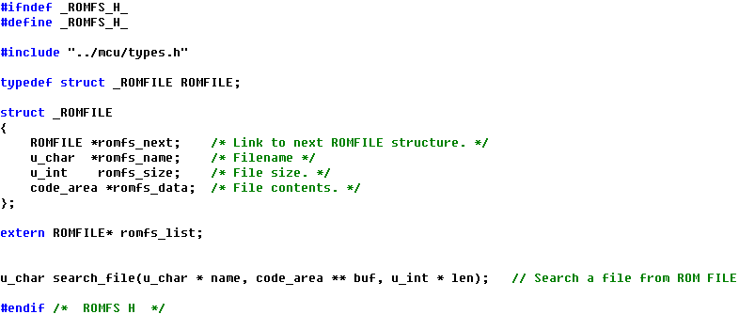
<Fig 4.6> “romfs.h”
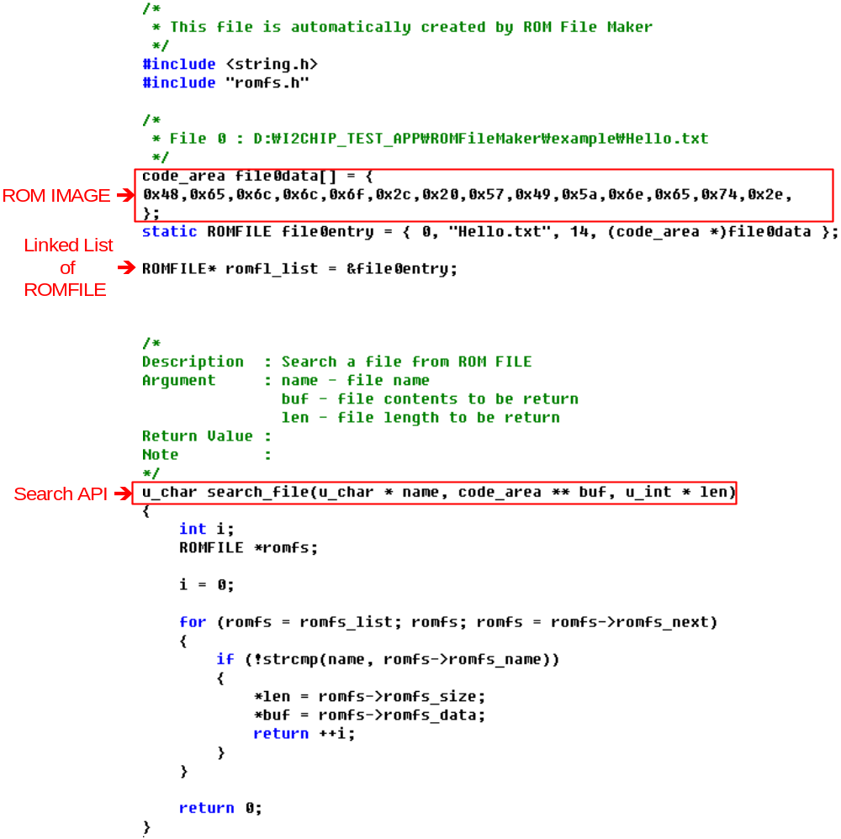
<Fig 4.7> “romfs.c”

